FACT SHEET UPDATED December 3, 2025

A Canadian junior natural resource company listed on the TSX Venture Exchange, the Frankfurt Stock Exchange and the OTCQB. Noble Mineral Exploration Inc.,
holds exploration rights in ~94,567 mineral rights in various areas of Northern Ontario and Quebec upon which it plans to generate joint venture exploration programs.
 |  | Project Generator 2025
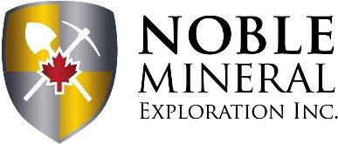
Exchange: Symbol
TSX.V: NOB |  | Focused on Battery and Critical Minerals  - Project 81 ~18,000ha in the Timmins-Cochrane area of Northern Ontario, for which it holds the exploration rights for VMS and Gold available for option, including the Dargavel and Lucas Gold Trends;  - Mann et al Twps ~38,700ha in East Timmins Nickel Inc. for Nickel-Cobalt/PGM in the Timmins area of Northern Ontario. Canada Nickel owns 80% - Noble retains a 20% ownership;  - Thomas Carbonatite ~ 2,215ha Rare Earths (REE) property near the Timmins area in Northen Ontario;  - Nagagami River Carbonatite ~4,600ha Niobium and Rare Earth discovery near Hearst in Northern Ontario available for option;  - Boulder Project ~3,200ha drilled in 2023 to follow up Airborne EM/Mag for Boulder producing 70%+ Copper;  - Holdsworth Gold ~304ha gold project near Wawa, Northern Ontario  - Cere-Villebon ~1,573ha near Val d’Or, Quebec with historic Copper-Nickel-PGM results on the property with drilling results reported July 2023;  - Buckingham Graphite ~3,700ha in the Outaouais area of Western Quebec with large flake recoverable graphite with NI 43-101 Report April 2023;  - Havre St Pierre ~10,152ha untested Nickel, Copper, Gold Prospect with follow up airborne Q4 2023;  - Chateau ~ 569ha Uranium-Rare Earths-Phosphorus-Silver property in the Kitivik area of Northern Quebec;  - Taser North ~461ha Uranium-Molybdenum 10 claim property in Northern Quebec;  - Mehmet ~4,465ha REE 90 claim property in Northern Quebec;  - Gull Lake ~ 3,000ha REE property – 54 map-staked units;  - Chapiteau ~ 647ha – 25 map claims, with REE occurrences reported by Midland Exploration Inc from a 2010-2011 program.  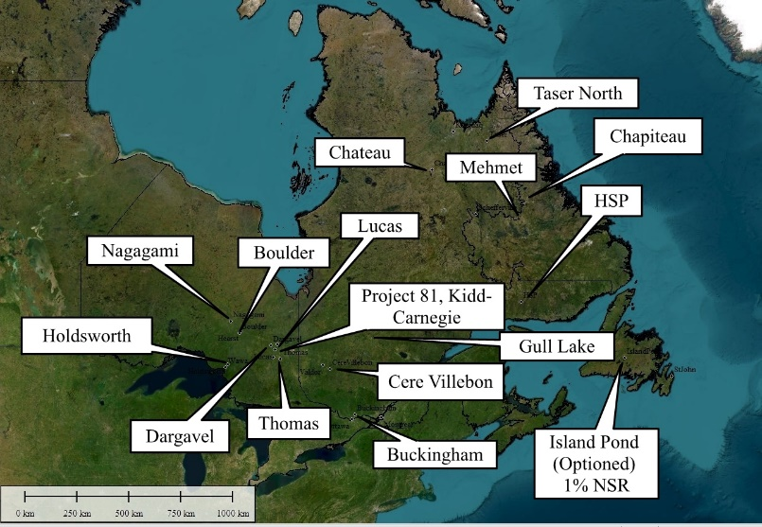
FWB: NB7
OTCQB: NLPXF
As of December 23 2025
Cdn. $0.08
52 week Hi-Lo
Cdn $0.08 - $0.03
Shares Outstanding
254.4 million
Warrants O/S
18.1 million
Options/RSU’s O/S
9.3 million
Fully Diluted
Approx. 282 million
Market Capitalization
~ $20.3 million
Year End
August 31
Financial Reports:
www.sedar.com
Transfer Agent:
TMX Equity Transfer
Services
Investor Relations
info@noblemineralexploration.com
www.noblemineralexploration.com
Qualified Person: All projects are conducted under the
Supervision of Noble’s Exploration Manager Wayne Holmstead PGeo
The Company’s Qualified Persons under the meaning of
NI 43-101 are
Michael Newbury P.Eng Wayne Holmstead P.Geo

UPDATED December 3 2025
TSX.V: NOB  FWB: NB7 OTCQB: NLPXF |  | Other Projects
Head Office:
120 Adelaide Street W. |  | RECENT CORPORATE ACTIVITIES  - In 2020 Noble spun out a pure play Nickel-Cobalt-PGM Company - Canada Nickel Company (CNC.V) and transferred 100% interest in the Crawford Nickel-Cobalt Project into Canada Nickel;  - The Company assigned a 2% NSR Royalty interest on all the patented lands to Franco-Nevada Corporation (FNV.TSX) and retains a 2% NSR on all staked mining claims;  - The Company re-acquired the Holdsworth Gold property from MacDonald Mines;  - The Company acquired in 2021 the Buckingham Graphite property, the Cere-Villebon Ni/Co/PGM property, both of which are in Quebec;  - The Company owns 224 mining claims (~4,600 ha) for Niobium and Rare Earths in the Nagagami River Carbonatite complex north west of Hearst Ontario;  - In 2022 the Company completed the sale of 7 properties to Canada Nickel for 3,500,000 shares which were dividended out to the Noble shareholders by way of Return of Capital;  - The Company staked 188 mining claims (10,152ha) in the Havre St Pierre area of Quebec, with Airborne survey flown Q4 2023;  - Noble has recently acquired a Rare Earth property (2,215 ha) in the Thomas Twp, near Timmins, Northern Ontario;  - In 2025, the Company vended its interest in Project 81. Noble retains 5-yr exploration rights to explore for gold, silver, copper, lead and zinc;  - The East Timmins Nickel Inc (ETN) – (see NR 2025-02-26) ~38,700 ha Nickel-Cobalt-PGM property in the Mann et al twps. In the Timmins area of Northern Ontario. Noble retains a 20% interest in ETN;  - Chateau - a 569ha Uranium/Rare Earths property in the Kitivik area of Northern Quebec;  - Taser North – a 461ha Uranium/Molybdenum property in Northern Quebec;  - Mehemet ~4465ha REE property in Northern Quebec;  - Gull Lake ~3,000ha REE property in Northern Quebec;  - Chapiteau ~ 647 ha – 25 map staked claims in Labrador, with REE occurrences reported by Midland Exploration Inc from a 2010-2011 program.  Canada Nickel Company Shareholding  1,900,000 shares of Canada Nickel Company Inc  Homeland Nickel Shareholding  19,500,000 shares and 750,000 2-yr warrants of Homeland Nickel Inc.  Benton Resources Shareholding  1,000,000 shares of Benton Resources.  East Timmins Nickel Inc.  Noble owns a 20% interest in the Company, which is owned by Canada Nickel Company.  The material contained in this publication is for information purposes only  and does not constitute an offer to sell or buy the security. The material is not all-inclusive.
Suite 2500
Toronto, ON M5H 1T1
Ph: 416-214-2250
Fx: 416-367-1054
eMail:
info@noblemineralexploration.com
Website:
www.noblemineralexploration.com
Twitter: @NobleMineral
LinkedIn: Noble Mineral Exploration
Investor Relations
Ph: 416-214-2250
info@noblemineralexploration.com
Executive Team:
H. Vance White
President, CEO & Director
Wayne Holmstead P.Geo
Exploration Manager
Robert Suttie
Chief Financial Officer
Mike Newbury P.Eng
Director
Birks Bovaird
Director
Yvan Champagne
Director
Dr. Samuel Peralta
Director
Stephen Balch P.Geo
Special Advisor/Consultant
Ed van Hees P.Geo
Consultant
Denis Frawley
Corporate Secretary
Investor Relations & Corp. Communications
H. Vance White
info@noblemineralexploration.com

